**INTRODUCTION**

The design of our Formula Student electric vehicle is driven by multiple targets, including performance, safety, and efficiency. The project aims to achieve competitive results in key events such as the Acceleration, Endurance, Autocross, and Skid pad events. From the outset, the design focuses on optimizing weight distribution, improving powertrain efficiency, and enhancing the overall structural integrity of the car. The main goal is to provide a reliable and high-performing vehicle within the strict guidelines and rules of the Formula Student competition.

The vehicle design followed a target-based methodology, with each domain setting specific targets aligned with the overall vehicle goals. These targets included:

• Completing the Acceleration Event within 6 seconds

• Minimizing the time for the Endurance Event

• Maximizing power delivery to the wheels for high performance

• Optimizing weight distribution and vehicle compactness

• Ensuring serviceability and reliability throughout the vehicle

• Achieving a balance between performance, efficiency, and safety

The methodology involved each domain setting its own targets based on these overall goals. The design, sizing, and selection of components were carried out to meet specific individual targets. Once the components were designed, an interference and compatibility check were performed by bringing all the domains together to assemble their designs. This iterative process was repeated until a single design was finalized that met all targets with minimal compromise.

Manufacturing was carefully planned, with processes like CNC machining and laser cutting ensuring precision and serviceability. Through multiple iterations, the final vehicle design was achieved, meeting performance, reliability, and safety targets.

**DRIVETRAIN**

**Motor**

Taking the Acceleration Event as a target as it requires the peak power output from the powertrain, the ‘acceleration work’ of the powertrain was calculated and the net power delivered by the wheels was calculated as **56.973 kW** and the required starting torque as **452.32 Nm.**

After matching our requirements with the available traction motors,we chose the Emrax 228 Medium-Voltage Liquid-Cooled Motor for its high power-to-weight ratio, efficiency, torque density, compact size, high voltage operation, customization options, high RPM capability, and reliability. These features make it ideal for enhancing the performance of our Formula Student electric car.

Thus, considering the clear superiority of the motor over others available in the market, it was decided that the accumulator should allow the motor to be sized appropriately. Since the regulations do not allow an excess of 80kW of power to be generated or delivered, the 100kW motor was deemed safe for use at 80kW of input power.

**Accumulator**

Our Previous car’s accumulator was made from 18650 cells. However, due to the increased requirement from the motor, we had to look for higher power alternatives. This gave us two options, cylindrical 21700 cells or pouch cells. We chose 21700 cells (Molicell P42A) because of enhanced mechanical stability and robustness, making them more resistant to physical stress. Their compact design simplifies assembly, while their sturdy construction ensures safer storage and use, reducing the risk of swelling or leakage. They also costed less than the pouch cells with similar or better power.

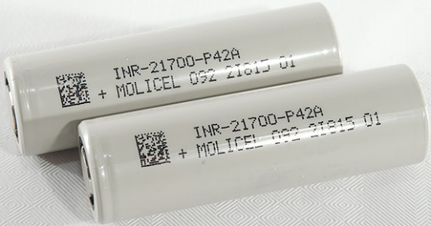

**Molicell P42A (NMC cells)**

* **Type:** 21700 Lithium-ion Cell
* **Max Voltage :** 4.2V
* **Nominal Voltage:** 3.6V
* **Capacity:** 4200mAh (4.2Ah)
* **Continuous Discharge Rate:** 45A

To do the accumulator sizing, MATLAB codes were generated using simple equations to identify which accumulator configuration would give us the required results. Out of the different iterations performed, the configuration of 80 cells in series and 8 cells in parallel provided the least theoretical time in acceleration and the best top speed and closely align with our target ideal values.

|  |  |  |
| --- | --- | --- |
| **Maximum Voltage developed** | **Maximum Current discharged** | **Maximum Power Produced** |
| V = 50*4.2 = 210 V | I = 8*4.2*7 = 235.2 A | P = V*I = 210*235.2 = 49,392W = 49.39kW |

This accumulator size maximizes the power limit allowed under current regulations while accommodating an appropriately sized motor. Further the accumulator was divided into 5 segments of 10s 8p configuration to follow the stack energy requirements and make the stack weight safe and manageable for working.

**Stack Construction:**

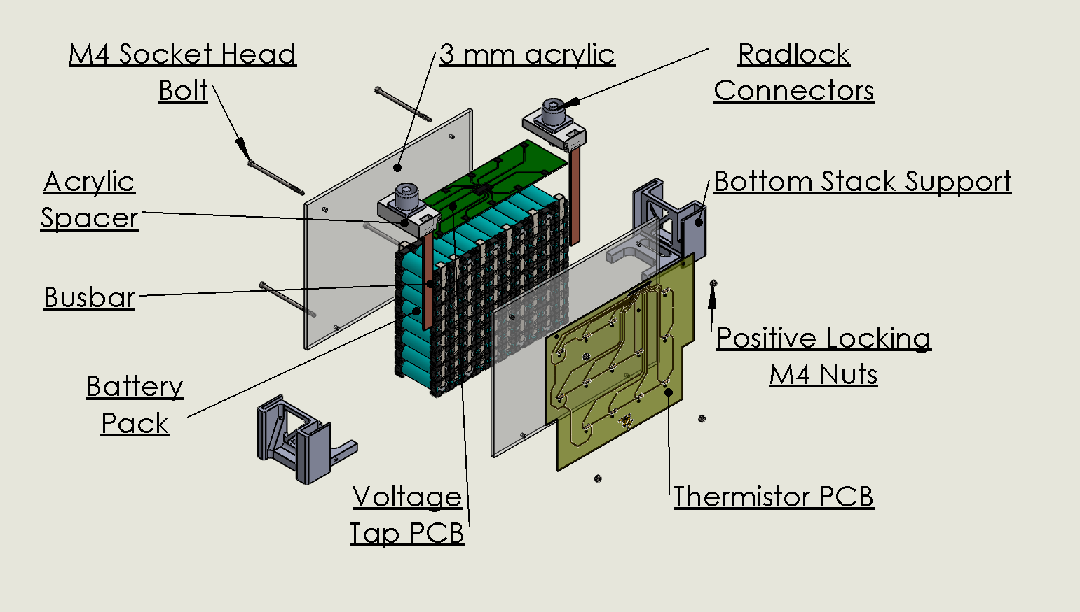

The cells are held together using cell holders. For current, the nickel strips are spot welded to the cell which are then soldered to the busbar. This assembly is sandwiched between two plates of acrylic which are bolted together through mounts at each corner. This ensures the locking of the cells. The busbars are connected to the maintenance plugs. There are 2 PCBs on the stack namely voltage tap PCB for monitoring cell voltages and Thermistor PCB for measuring the temperatures of 30% of the cells as mandated by the rules. The cells are spot welded with nickel strips. The voltage leads are being used by the ORION BMS 2 for cell balancing.

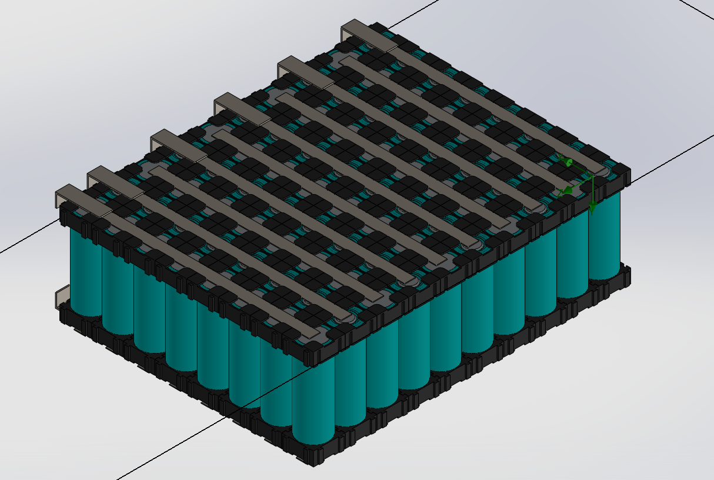

So we have 5 segments of **10s8p** in series that makes our battery pack configuration 50s8p.

**Max Voltage of each Segment: 42V**

**Nominal Voltage of each Segment: 36V**

**Capacity:33.6Ah**

**Max Energy per Stack : 5.08 MJ**

**Each of the five segments is connected in series by use of radlocks.**

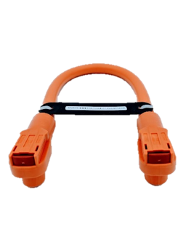

**Accumulator Container Design**

The Container is fabricated with a mix of Aluminum 6061 T6. The container consists of 5 compartments for each of the stacks and another compartment which is divided to fit the components like the Fuse, AIRs, Voltmeter, BMS, IMD and other components.

The walls separating the segments are bolted onto the container and a lid covers the seals with the entire assembly. The accumulator is cooled by using a total of 4 exhaust fans which get the fresh air intake from the bottom.

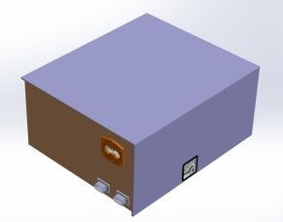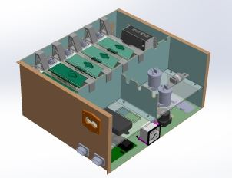

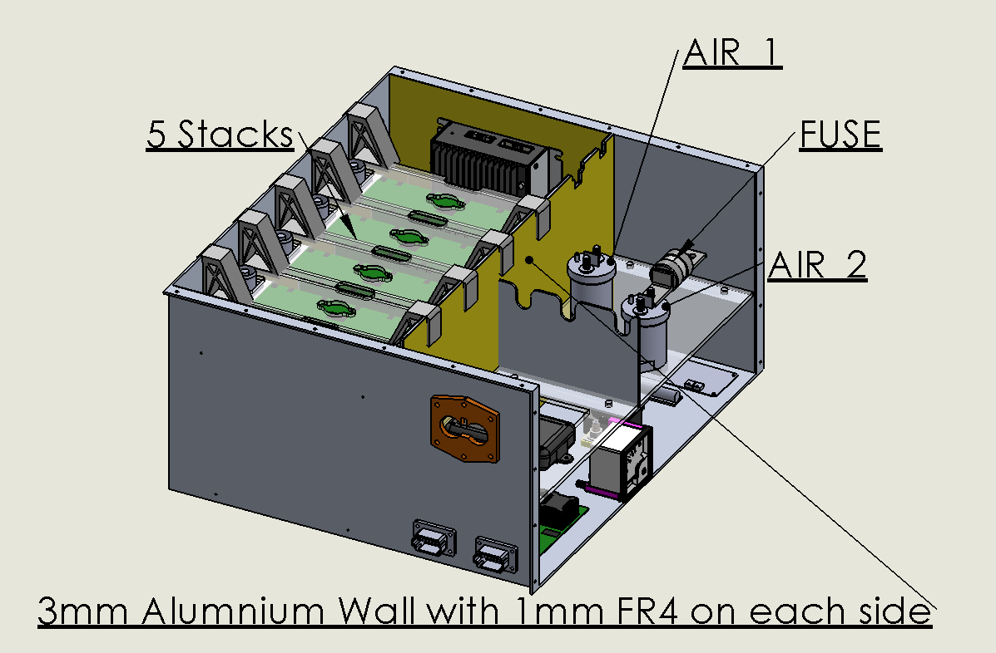

**Battery management system**

The BMS system we have selected to use is Orion Battery Management System. The system is a distributed type system where the cells are physically apart from the BMS controller. BMS is powered by the 12V auxiliary battery supply. The BMS has one power input, one always on power and one standby power. The BMS system can monitor a voltage range of 0.5 to 5 VDC powered by the 12V auxiliary battery supply. The BMS has one power input one always on power and one standby power. The BMS system can monitor a voltage range of 0.5 to 5 VDC. Wiring protection is not required since BMS has internal fusing.

Lithium ion has a maximum voltage of 4.2 V and minimum of 2.7V, which will be programmed in the BMS controller. Cell voltage measurement total error <0.25% across full temperature range. The operating temperature for BMS is -40 C to 80 C. For lithium ion cell, the maximum allowed temperature is 60°C. The temperature can be adjusted to fit our needs in BMS i.e 60 C for Li based cells. So, BMS will measure the temperature of cells using thermistors and if an over temperature event takes place, it opens the shutdown system and disables the AIR and the cells will have to cooled before they can be used. The BMS control unit supports over cells in 108 series. The configuration of cells is 50s8p. The accumulator is divided into 5 segments, each segment consisting of 10 series and 8 parallel. The BMS monitors the health of both individual cells and the total pack and will trigger error trouble codes if either the pack or individual cells are in poor health.

**Voltages taps: 50 voltage taps**

**Thermistors : 14 per segment(70 thermistors total)**

10K NTC Thermistors with a B25/50 value of 3380K

We have to monitor atleast 24 cells of each segment so we decided to put the thermistors between the two cells and used thermistor PCB to route them till the thermistor module which further sends the data to Orion BMS 2 via CANBUS.

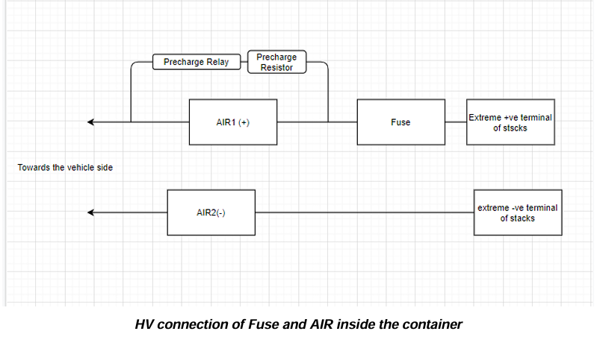

For wiring HV we made use of 50mm2 unshielded orange wires .